**CACIE Tool** – ***Build Surface Flux (build_surface_flux.py)***

**Version** **1.0**

**QA**: **TEST** or **NA** or **QA**

1. **Description and Purpose**

The Build Surface Flux tool reads a STOMP input file and extracts the grid card. The tool then reads a MODFLOW shapefile and extracts the corresponding grids that are within the STOMP grid coordinates. It then creates a ~surface flux card, mapping the STOMP grid into the MODFLOW grid.

1. **Functional Requirements**

The functional requirements of the Build Surface Flux tool are as follows:

FR-1: Parse arguments

FR-2: Extract STOMP Grid template (~Grid Card)

FR-3: Build x index values based on input file STOMP Grid template

FR-4: Build y index values based on input file STOMP Grid template

FR-5: Find all MODFLOW shapefile nodes that fall within the STOMP x-y boundaries

FR-6: Find all applicable x-indices for each MODFLOW shapefile grid from FR-5

FR-7: Find all applicable y-indices for each MODFLOW shapefile grid from FR-5

FR-8: Write to surface flux card text file: for each MODFLOW grid from FR-5, summarize the relevant STOMP coordinate indices for each contaminant.

1. **Software Requirements Specifications**

The following are the software requirements for the Build Surface Flux tool with regards to programming language and versioning and the associated dependencies on libraries and/or modules.

* Python 3.5
* Libraries:  
  pyshp  
  shapefile  
  datetime  
  os  
  argparse  
  logging  
  itemgetter from operator

1. **Software Design Description**

The following is a brief description of required arguments and inputs, invoked functions, and the output generated by the Build Surface Flux tool.

* Arguments:  
  contaminants   
  MODFLOW shapefile to use (input file: “.shp”)  
  STOMP input file to get grid card from (input file: “input”)  
  model name   
  output filename (output file: “.txt”)
* Functions:  
  (obsolete)validate_contaminates(contaminates): validate contaminates names

setup_logger (name, log_file, level=logging.INFO): set up Log handler

get_variables(filename): read ~grid card from file

build_ind(text,num): build stomp indices

build_shp_grid (shpfile,ind_x,ind_y,num_x,num_y): read in shape file then find all

MODFLOW grids relevant to the STOMP grid (coordinates within STOMP indices)  
write_outputs(template): output ~solute flux card and csv of STOMP file grid to shape file grid conversion

* .sh file: runner_run_ca-surf_rad1.sh
* python ../../tools/pylib/runner/runner.py “python3” “../../tools/ca-surf/ca_build_surface_flux.py -c C-14 Cl-36 H-3 I-129 Np-237 Re-187 Sr-90 Tc-99 -shp "../../tools/ca-surf/grid_attempt1/grid_attempt1.shp" -i "../ss/input" -s ModelName -o "./rad1_surface_flux.txt"”
* Basic usage: -c contaminates, -shp shape file to use, -i stomp input file to get grid card from, -s what model this is for, -o (optional) file name and directory to create the surface flux card
* .sh file: runner_run_ca-surf_rad2.sh
* python ../../tools/pylib/runner/runner.py “python3” “../../tools/ca-surf/ca_build_surface_flux.py -c U-232 U-233 U-234 U-235 U-236 U-238 Th-230 Ra-226 -shp "../../tools/ca-surf/grid_attempt1/grid_attempt1.shp" -i "../ss/input" -s ModelName -o "./rad2_surface_flux.txt"”
* Basic usage: -c contaminates, -shp shape file to use, -i stomp input file to get grid card from, -s what model this is for, -o (optional) file name and directory to create the surface flux card

Code walkthrough was performed by Sara Lindberg on 06/11/2019. A limited number of editorial comments were made but none of the comments or their resolution impacted the functionality of the tool itself. A summary and resolution of the comments is presented in Appendix A, Table A-1.

1. **Requirements Traceability Matrix**

Table 1 presents the requirements traceability matrix for the Build Surface Flux tool.

| **Table 1. Build Surface Flux Tool Requirements Traceability Matrix** | | |
| --- | --- | --- |
| **Functional Requirement** | **Acceptance Test** | **Test Case** |
| QA Level | IT-1 | Installation Test |
| FR-1 | ATC-1 | check log file values against arguments |
| FR-2 | ATC-2 | check log file values against STOMP input file |
| FR-3 | ATC-3 | check log file values against STOMP input file (..\ss\input) |
| FR-4 | ATC-4 | check log file values against STOMP input file |
| FR-5 | ATC-5 | check log file values against STOMP x-y boundaries |
| FR-6 | ATC-6 | check contaminants and x-indices for one node |
| FR-7 | ATC-7 | check contaminants and y-indices for one node |
| FR-8 | ATC-8 | check rad[]_surface_flux.txt nodes against log file nodes |

1. **Test Plan and Cases**

The test plan and results for the Build Surface Flux tool is as follows.

| **Table 2. Build Surface Flux Tool Test Plan** | | |
| --- | --- | --- |
| **TEST ID** | **Test Case** | **Test Result  (Pass/Fail)** |
| IT-1 | Installation Test | Pass |
| ATC-1 | check log file values (see Appendix A Attachment A-1) against arguments (see runner_run_ca-surf_rad1.sh text in Section 4) | Pass |
| ATC-2 | check log file values against STOMP input file (see Appendix A Attachment A-2) | Pass |
| ATC-3 | check log file values against STOMP input file | Pass |
| ATC-4 | check log file values against STOMP input file | Pass |
| ATC-5 | check log file values against STOMP x-y boundaries | Pass |
| ATC-6 | check contaminants and x-indices for one node in check rad[]_surface_flux.txt (see Appendix A Attachment A-3) | Pass |
| ATC-7 | check contaminants and y-indices for one node in check rad[]_surface_flux.txt | Pass |
| ATC-8 | check rad[]_surface_flux.txt nodes against log file nodes | Pass |

See appendix for the corresponding acceptance test case test logs as noted in the test case descriptions.

1. **Acceptance Test Report**

The test report will state whether the tool is qualified for use, summarize test case results, and report all resolved incidents and resolution of unresolved incidents.

Acceptance testing was performed in accordance with the test plan documented in Section. 6. The Build Surface Flux tool met the functional requirements as documented in Section 2. Verification of the tool’s functionality is documented in the test logs included in Appendix A. There were no incidents requiring resolution and accordingly, there are no unresolved incidents.

1. **User Guide**

A guide for using the tool will be documented in this section.   
Command line Arguments:

-s: Name of Sim Model, defaults to “Unknown”

-I: location and name of the input file with the ~grid card to be used. Defaults to the sim template

-shp: (Required) shapefile with the ground water grid to be used

-c: Constituents used in this model, Defaults: ”Tc99”, “I129”, “Sr90”, “U233”, “U235”, ”U238”

-n: (Required) Name of person running the script

-o: Directory and name of output file default: output/{model}/{date}/_solute_flux_card.txt

-csv: location to create csv file to check shapefile grid to stomp grid conversion. default: csv/{model}/{date}/{model}_grid_conversion.csv

-b: turn on boundaries for solute flux and Aqueous Volumetric. exampe: BNS will turn on bottom, North, and South. example 2(default): B will turn on bottom only

**Appendix A**

**Code Review Summary   
and   
Acceptance Testing Logs**

| **Table A-1. Build Surface Flux Tool Code Review Summary** | | | |
| --- | --- | --- | --- |
| **Code Line** | **Comment** | **Notes** | **Resolution** |
| 49-64 | Function “validate_contaminates is not called in main body of code | No impact to functional requirements |  |
| 95,99, 101,103 | As written code truncates last character in string; for lines 99,101,103: end up with an empty string member in list (example: stomp grid y = [‘573100’, ‘m’, ‘60@10, ‘’] | No impact to functional requirements but suggest the following: grid.append(l.split(‘,’)) |  |
| 220 | Is this list of contaminates still needed? | No impact to functional requirements |  |
| 393 | Variable y_nodes never referenced | No impact to functional requirements |  |
| 394 | Variable x_nodes never referenced | No impact to functional requirements |  |

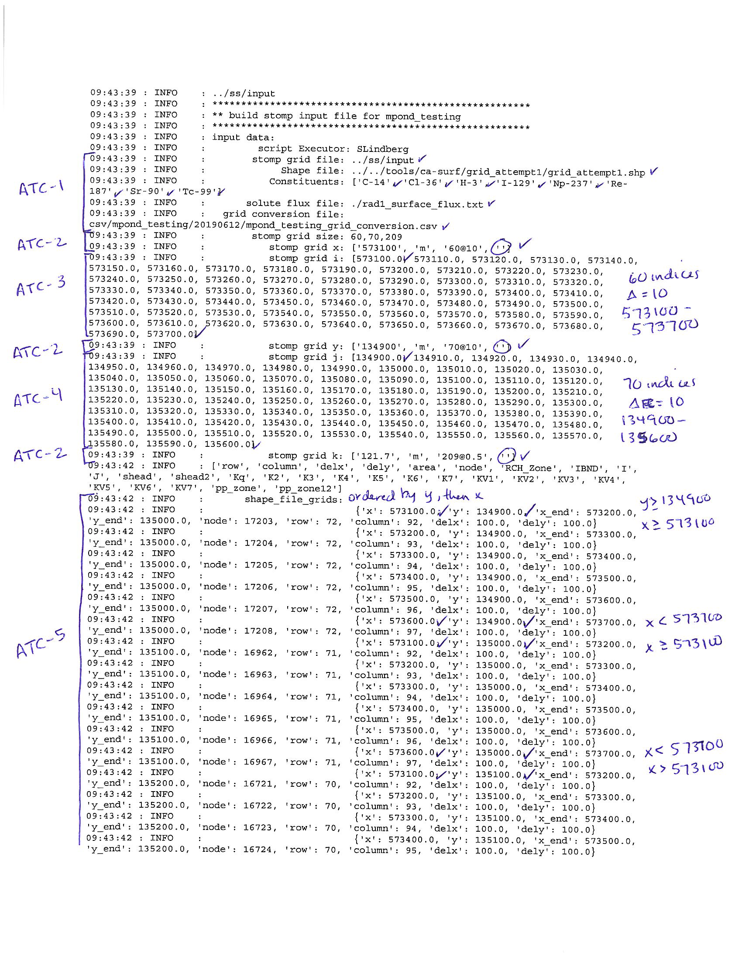

**Attachment A-1. Build Surface Flux Tool Log File (page 1 of 2)**



**Attachment A-1. Build Surface Flux Tool Log File (page 2 of 2)**



**Attachment A-2. STOMP Input File (page 1 of 1)**



**Attachment A-3. Output File Generated by the Build Surface Flux Tool  
Rad1_surface_flux.txt (page 1 of 7)**



**Attachment A-3. Output File Generated by the Build Surface Flux Tool  
Rad1_surface_flux.txt (page 2 of 7)**



**Attachment A-3. Output File Generated by the Build Surface Flux Tool  
Rad1_surface_flux.txt (page 3 of 7)**



**Attachment A-3. Output File Generated by the Build Surface Flux Tool  
Rad1_surface_flux.txt (page 4 of 7)**



**Attachment A-3. Output File Generated by the Build Surface Flux Tool  
Rad1_surface_flux.txt (page 5 of 7)**



**Attachment A-3. Output File Generated by the Build Surface Flux Tool  
Rad1_surface_flux.txt (page 6 of 7)**



**Attachment A-3. Output File Generated by the Build Surface Flux Tool  
Rad1_surface_flux.txt (page 7 of 7)**